GitHub link: <https://github.com/TanLaura/TECHIN512-Lab1>

Screenshots:

**Build Log**

Init

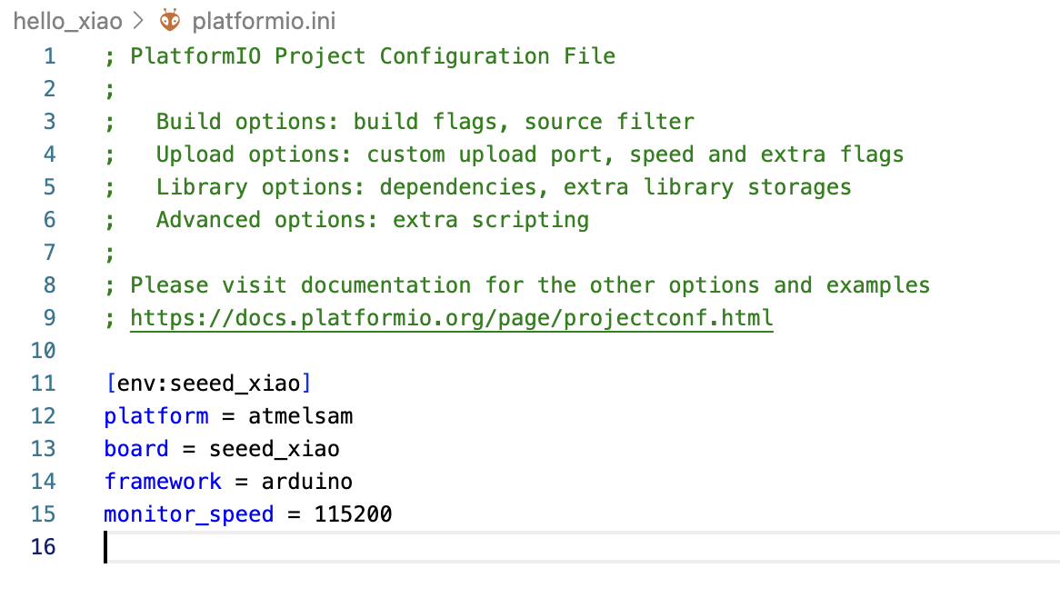

Code just for reference

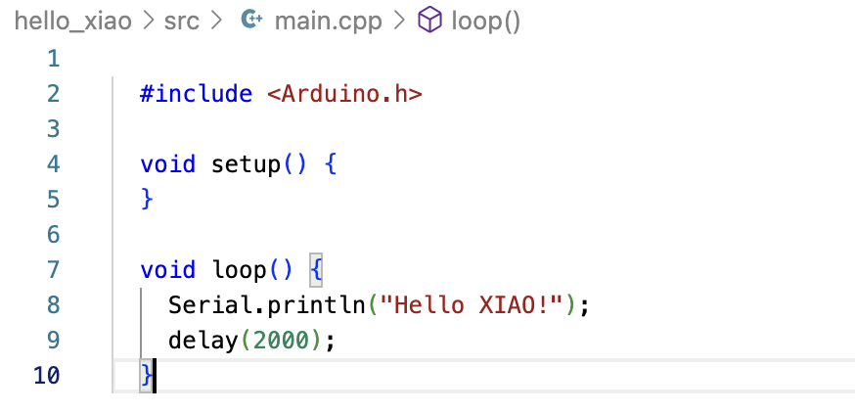

Hello Xiao Build

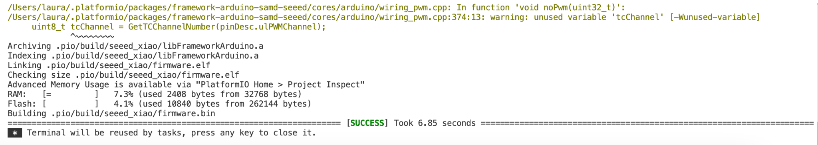

Serial Monitor Output

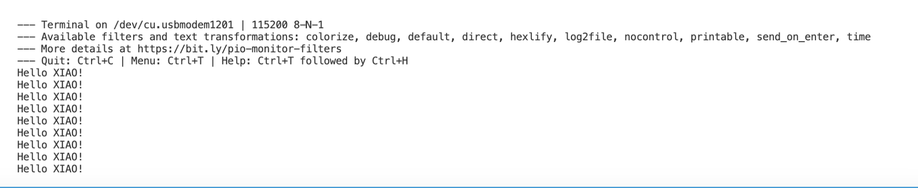

Github repository screenshot

